**Anthony Legg**

**38 Bradford Street,**

**Bradford,**

**Dunedin 9011**

**Cell: 027 452 6255**

**Email: anthony.legg@outlook.com**

**1st February 2013**

Dear Sir/Madam

With reference to the current vacancy of ‘Receptionist’ within the Commerce Division, I would like to register my interest in this position.

Currently I am employed by the University of Otago as a Receptionist in the Office of the Dean, within the Commerce Division. This position has given me a great insight into the unique culture of the University and the way it operates to benefit staff and students alike.

My current CV is attached for your perusal and I am available for interviews at your earliest convenience.

Thank you for your interest in my application.

Yours faithfully

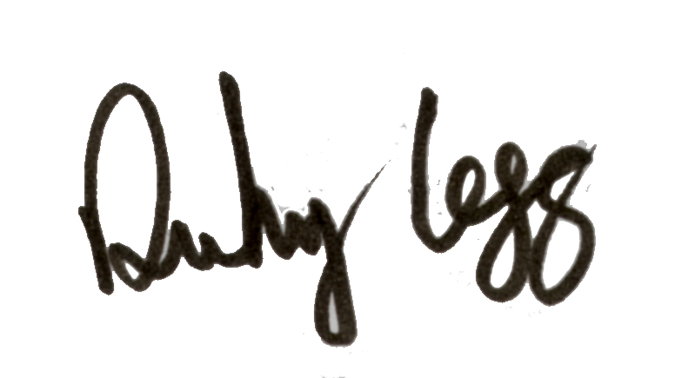

Anthony Legg